# *Database Management I (420-D10-HR)*

# *Lab 06 - The Conceptual Data Model*

Date assigned: Monday, September 12, 2016

Date due: **Monday, September 12, 2016, 4:50 pm**

**Learning Objectives**

Upon successful completion of this lab exercise, the student will be able to:

1. identify, name and define entities from a set of business rules.
2. identify, name and define relationships from a set of business rules.
3. draw a conceptual data model.
4. recognize and correct connection traps.

**To Be Handed In:**

1. The completed ***username_*D10_L06_Answers.docx** document should be uploaded to **Moodle**.

**Marks:**

|  |  |  |  |
| --- | --- | --- | --- |
| **Question** | | **Mark** | **Out Of** |
| A | 1. Entity Definitions for the real estate firm |  | 10 |
|  | 2. Relationship Definitions for the real estate firm |  | 16 |
| B | 1. Hospital Data Model |  | 8 |
|  | 2. Online catalogue Data Model |  | 7 |
|  | 3. Conceptual Data Model for the real estate firm |  | 12 |
| Connection Traps | |  | 8 |
| Organization | |  | 3 |
| Correct Use of English (as per College policy #36) | |  | 3 |
| Total | |  | 67 |

**To Start:**

1. Rename this document ***username*_D10_L06_Conceptual_Data_Model** in your **420-D10\Labs** folder.
2. Complete the document as instructed in the lab.

# Definitions

***Purpose:*** Learn to write entity and relationship definitions.

***References:***

### 1. The guidelines on "Data Names and Definitions" and "Naming and Defining Entity Types" (in Moodle for this lab)

2. The following description of a real estate firm that lists properties for sale

* The firm has a number of sales offices in several states. Attributes of sales office include Office_Number (identifier) and Location.
* Each sales office is assigned one or more employees. Attributes of employee include Employee_id (identifier) and Employee_Name. An employee must be assigned to only one sales office.
* For each sales office, there is always one employee assigned to manage that office. An employee may manage only the sales office to which he or she is assigned.
* The firm lists property for sale. Attributes of property include Property_id (identifier) and Location. Components of Location include Address, City, State, and Zip_Code.
* Each unit of property must be listed with one (and only one) of the sales offices. A sales office may have any number of properties listed or may have no properties listed.
* Each unit of property has one or more owners. Attributes of owners are Owner_id (identifier) and Owner_Name. An owner may own one or more units of property. An attribute of the relationship between property and owner is Percent_Owned.

***To Do:***

## Identify and define the entities. Be sure that you follow the guidelines for names and definitions.

Entity Definitions

| **Entity Name** | **Definition** |
| --- | --- |
| Office | Multiple sales offices with different locations.  Each office has an office number.  Each office has a location.  Each sales office is assigned one of more employees.  Each office has one manager.  An office may have any number of properties listed (including 0) |
| Employees | Each employee has an employee ID.  Each Employee has a name.  Each employee is assigned to only one office.  An employee can be assigned as manager to one office. |
| Owner | An owner has an owner ID and a name.  An owner may own one or more pieces of property.  The relationship between the property and owner is the percent_owned |
| Properties | Each property has a property ID and a location.  The location contains the address, city, state and zip code  Each property is listed with only one sales office. |

## Identify and define the relationships. Define both directions of a relationship. (e.g. both *STUDENT registers in COURSE* and *COURSE has registered STUDENT*). Decide on the optionality and cardinality for each relationship. (Optionality is the minimum cardinality.). Be sure that you follow the guidelines for names and definitions.

Relationship Definitions

| **First Entity** | **Second Entity** | **Relationship Name** | **Cardinality** | | **Relationship Definition** |
| --- | --- | --- | --- | --- | --- |
| **Min[1]** | **Max** |
| Office | employee |  |  |  |  |
| Office | property |  |  |  |  |
| Employee | Office |  |  |  |  |
| Owner | property |  |  |  |  |
| Property | owner |  |  |  |  |
| Property | Office |  |  |  |  |
|  |  |  |  |  |  |
|  |  |  |  |  |  |
|  |  |  |  |  |  |
|  |  |  |  |  |  |
|  |  |  |  |  |  |
|  |  |  |  |  |  |

# Conceptual Data Model

***Purpose:*** Learn to draw a conceptual data model.

***To Do:***

Use **Oracle Data Modeler** to draw the following conceptual data models.

## Draw a conceptual data model that represents the following relationships in a hospital environment.

* A PHYSICIAN may admit one or more PATIENTs. A PATIENT is admitted by only one PHYSICIAN.
* Each PATIENT is assigned to only one WARD. Each WARD may contain many PATIENTs.
* A NURSE is assigned to only one WARD. A WARD may have many NURSEs working in it.
* Each NURSE is assigned one or more PATIENTs. A PATIENT is assigned three NURSEs (one for each shift).

Paste model here: 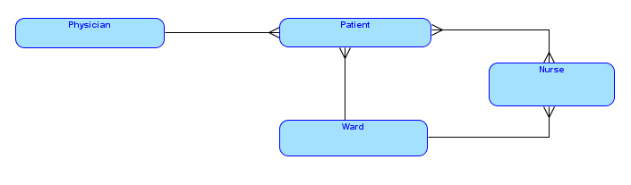

## Draw a conceptual data model for an online catalogue business in which customers can place orders for merchandise. All orders consist of one or more items. An item MAY appear on more than one order.

Paste model here: 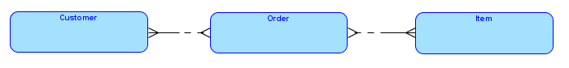

## Draw a conceptual data model for the Sales Office from Part I.

Paste Model here

# Connection Traps

***Purpose:*** Learn how to recognize connection traps and correct them.

**To Do:**

## Read up on Connection Traps in D10_N03.

## The following data model was drawn to represent the relationships between a musician and the albums and song he/she has recorded. However, this diagram contains a connection trap.

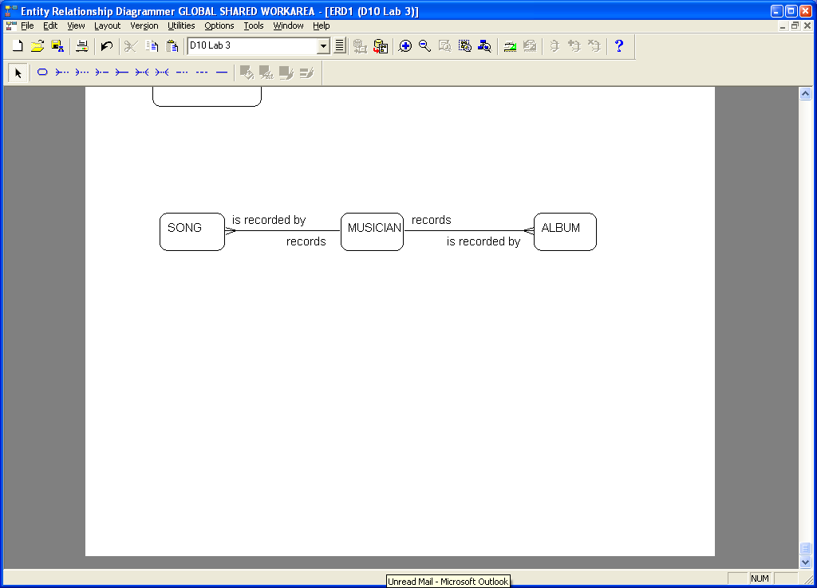

### Identify the type of trap and explain what the problem is in this particular instance.

Fan trap (Tie Fighter trap)

### Redraw the diagram in Oracle Designer with the trap corrected.

### A small company called *Geeks with Gears* employs a number of student technicians to repair computers in customers’ homes. They purchased a number of Austin minis emblazoned with their logo to make the repair visits. The company has recently franchised. A number of franchises have opened around the city. Each franchise hires and assigns its own technicians and is responsible for a bank of cars. When a technician goes on a call, he/she is assigned to a particular car. The following data model was drawn to represent the relationship between franchise, technicians and cars.



### The diagram contains a connection trap. Identify the type of trap and explain what the problem is in this particular instance.

Chasm trap

### Redraw the diagram in Oracle Designer with the trap corrected.

1. Optionality